**Core Java Assignment 5**

**Assignment on Generic**

**1.**

**import** java.util.HashSet;

**import** java.util.Iterator;

**class** Employee1{

**int** id;

String name;

String department;

**int** salary;

**public** Employee1(**int** id, String name, String department, **int** salary) {

**super**();

**this**.id = id;

**this**.name = name;

**this**.department = department;

**this**.salary = salary;

}

**public** String toString() {

**return** "Employee [id=" + id + ", name=" + name + ", department=" + department + ", salary=" + salary + "]";

}

}

**public** **class** EmployeeHashSet {

**public** **static** **void** main(String[] args) {

HashSet<Employee1> set=**new** HashSet<Employee1>();

set.add(**new** Employee1(1,"Chetana","IT",30000) );

set.add(**new** Employee1(2,"Aniket","Mech",25000));

set.add(**new** Employee1(3,"Shruti","IT",40000) );

set.add(**new** Employee1(4,"Sujit","CBO",50000) );

Iterator<Employee1> it=set.iterator();

**while** (it.hasNext())

{

Employee1 employee = (Employee1) it.next();

System.***out***.println(employee);

}

}

}

**Output:** Employee [id=2, name=Aniket, department=Mech, salary=25000]

Employee [id=4, name=Sujit, department=CBO, salary=50000]

Employee [id=1, name=Chetana, department=IT, salary=30000]

Employee [id=3, name=Shruti, department=IT, salary=40000]

**2.**

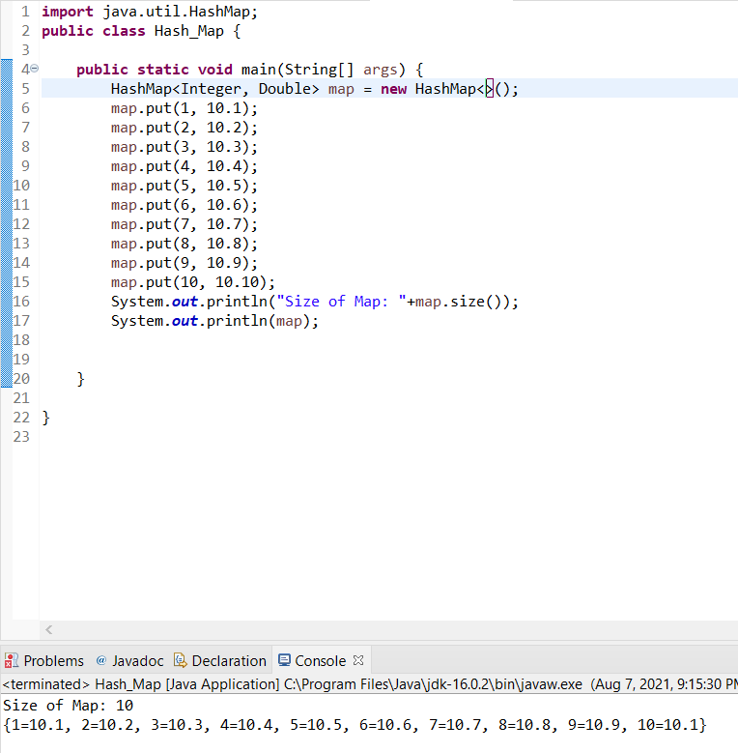

**3.**

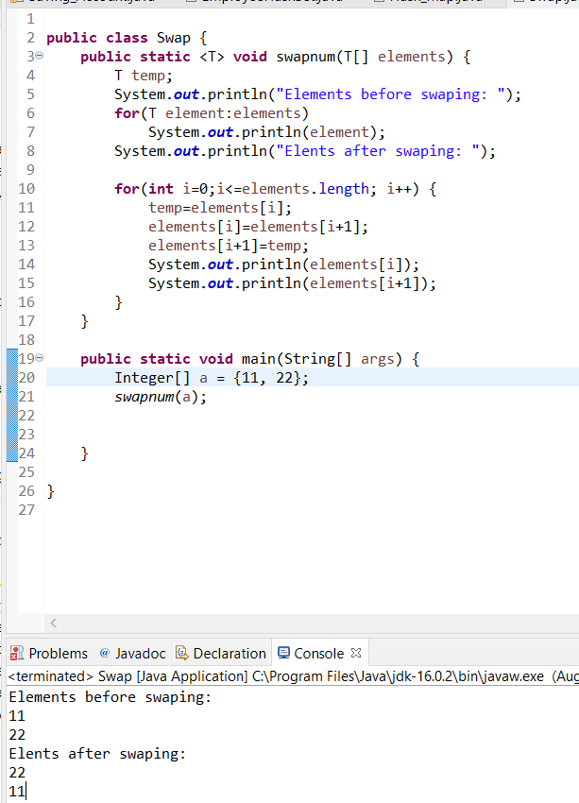

**4.**

